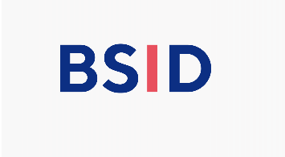
BSID Undergraduate Research Experience in Summer 2026
Application Form

Project Title:

Lab visit must take place in the summer 2026

Name of applicant:  Current Address: | Year of your study:  Email Address:
Name of Research Supervisor:  (must be a BSID member)  Address where research will be conducted: | Title:  Email Address:

Personal statement of applicant
(Outlining what you hope to achieve through your project, no more than 300 words)

Signatures: Please sign with electronic signatures

Applicant print name:

Applicant signature | Date:
Supervisor print name:

Supervisor signature | Date:

Application Conditions

Applications for the BSID Undergraduate Research Experience in Summer 2026 grants are open to any undergraduate student studying at a university in the UK or Ireland who proposes to undertake a research project related to dermatology or skin biology. Applications will only be considered from students who are at least in their second undergraduate year and onwards, and preference will be given to applicants who do not yet have any research experience and would therefore, particularly benefit from working on a summer project.

One grant of £1500 stipend and £500 consumables for a 6-week project in the lab is available. No top-ups or extensions are possible. The award has been funded by the British Association of Dermatologists.

Applicants must submit a completed application form with their CVs (one side of A4) to BSID committee at ukbsid@gmail.com

Closing date for applications is 12:00am midnight (GMT), 12th January 2026. If an application is not received by this deadline, it will not be processed and there will be no exceptions to this rule.

The BSID Committee will select one successful applicant with outcome notification in coming BSID annual conference.

The awardee is expecting to present his/her project at the next year’s BSID annual conference.

